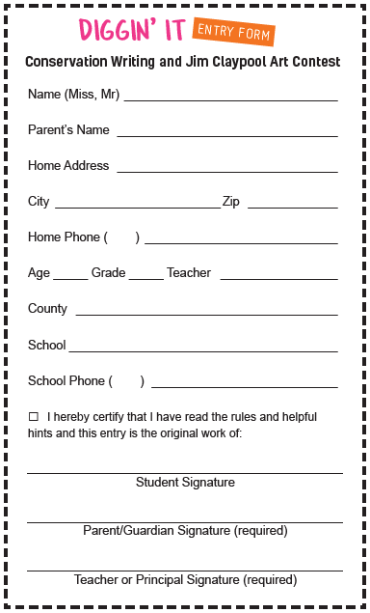

Each art or writing contest entry needs only entry form attached to the back of the entry.
There are 3 on this sheet for your convenience.
You may reposition or resize the forms as needed on this sheet.

